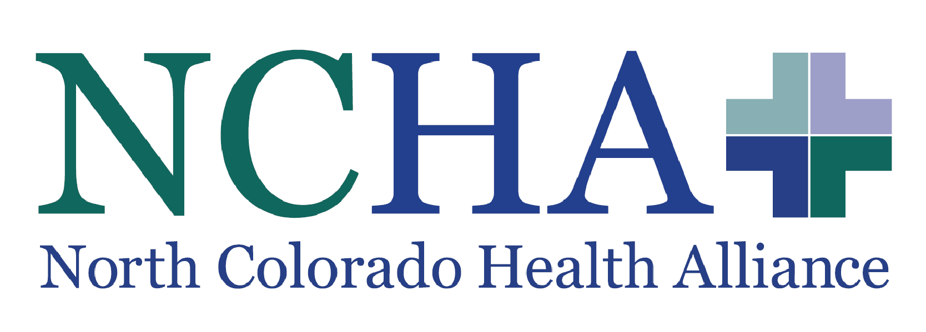

**Community Champion**

Welcome to Northern Colorado Health Alliance. You were selected to be Community Champions because of your experience with addiction and resolve to help others with theirs. Our programs are only as good as they can serve real people battling substance use disorder (SUD), for that reason, we believe your experience to be paramount to the future success of our events, programs, and community groups.

## Knowledge / Skills / Abilities

* Experience with persons who have an addiction, experience with opioid use disorder is especially preferred

## Cultural Competence especially as concerns substance related stigma and poverty (Medicaid, Medicare, uninsured populations)

* Honesty with one’s own experience and ability to empathize with others addiction and recovery process
* Strict Confidentiality
* Strong customer service skills
* Willingness to partner with local and regional health and human service resources
* Ability to work independently
* Reliable transportation

**Working Environment Physical Activities**

* Contact with the public by phone and in person
* Sitting
* Standing
* Walking
* Climbing up and down stairs
* Bending and reaching

**Job Responsibilities:**

* Act as member of the Northern Colorado Health Alliance and the CO-SLAW Team (Colorado Opioid Synergy Larimer and Weld County) to help design and implement community events and participate in community workgroup meetings.
  + Participate in quarterly family support programs through grant years two and three. These programs will address families and friends of people with SUD; increasing knowledge of opioid/naloxone, assisting families on how to move loved ones towards treatment, and advocating for their own health amidst their loved one’s recovery.
  + Help plan and implement an Opioid Awareness Day, Harm Reduction Symposium, and Rethinking Addiction through grant years two and three; events that will raise overdose awareness among community members, organization, and healthcare providers.
  + Attend twenty-four community workgroup meetings through grant year two and three of the CO-SLAW network and help connect community members to supportive services.
    - Responsibilities include presenting and sharing at meetings and events, engagement, and outreach to persons in the community for involvement and input in grant strategies, and monthly social networking responsibilities to recruit event attendees and promote training and events.
* Act as an ambassador to people currently experiencing substance use disorder by connecting them to the CO-SLAW network and other relative supportive/harm reduction measures.
* Completion of a 40 credit hour course as a Peer Recovery Coach.
  + The course can be completed virtually through four subsequent Saturdays from 8:30am to 5:30pm, or a single week of classes from 9:00am to 4:30pm.
  + This will provide the experience necessary to support the traumas of other community members, navigating other’s recovery while also living out the community champion’s own.

**Other Duties as Assigned:**

* Support of the mission and vision of NCHA
* Provide input into development of policies and procedures
* Compliance with NCHA programs overall
* Meeting and training attendance
* Participation in ongoing performance improvement activities

The above job definition information has been designed to indicate the general nature and level of work performed by employees within this classification. It is not designed to contain or be interpreted as a comprehensive inventory of all duties, responsibilities, and qualifications required of employees assigned to this job. Job duties and responsibilities are subject to change based on changing business needs and conditions.  
  
The North Colorado Health Alliance was incorporated as a 501(c)(3) non-profit organization in 2002. The Alliance, based in the town of Evans in Colorado’s Weld County, is a creative and strategic collaboration of partner organizations that are dedicated to cultivating the health of the communities they serve.  
  
At the Alliance, we recognize that health does not begin or end with medical, dental, and behavioral health services. Health also depends on features of the built environment and on a variety of social determinants that make it harder for many to resist the chronic illnesses of our times. Thinking globally, the Alliance acts locally and creatively to convene, integrate, and support community partners in our common effort to make northeastern Colorado the healthiest region in the healthiest state.